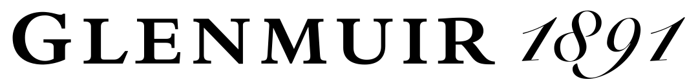
SIZE GUIDE
MEN’S GOLF POLO SHIRTS AND KNITWEAR
SIZE | EURO | CHEST (in) | CHEST (cms)
XXS | 44 | 34 – 36 | 87 – 92
XS | 46 | 36 – 38 | 92 – 97
S | 48 | 38 – 40 | 97 – 102
M | 50 | 40 – 42 | 102 – 107
L | 52 | 42 – 45 | 107 – 115
XL | 56 | 45 – 48 | 115 – 122
XXL | 58 | 48 – 50 | 122 – 127
XXXL | 60 | 50 – 52 | 127 – 132

WOMEN’S GOLF POLO SHIRTS AND KNITWEAR
SIZE | UK | EURO | BUST (in) | BUST (cms)
XXS | 4 – 6 | 32 – 34 | 28 – 30 | 72 – 77
XS | 6 – 8 | 34 – 36 | 30 – 32 | 77 – 82
S | 8 – 10 | 36 – 38 | 32 – 35 | 82 – 90
M | 12 – 14 | 40 – 42 | 35 – 38 | 90 – 97
L | 14 – 16 | 42 – 44 | 38 – 41 | 97 – 105
XL | 18 – 20 | 46 – 48 | 41 – 44 | 105 – 112

